xGit – Commands Assignment
Contents
Instructions: 1
TASK 1: Local Repository Setup 1
TASK 2: Remote Repository Creation 2
TASK 3: Connect Local Repository to Remote 2
TASK 4: Push Local Changes to Remote 2
TASK 5: Branch Creation and Work 2
TASK 6: Merge Branch into Main 2
TASK 7 – Final Sync with Remote 2
TASK 8 – Simple Pull 3
TASK 9 – Push and Pull with Conflict Resolution 3
TASK 10 - Clone an Existing Repository 3

Instructions:
- Commit messages must be meaningful
- Screenshots for each step in each task
- Follow steps in sequence

TASK 1: Local Repository Setup
- Create a new project folder.
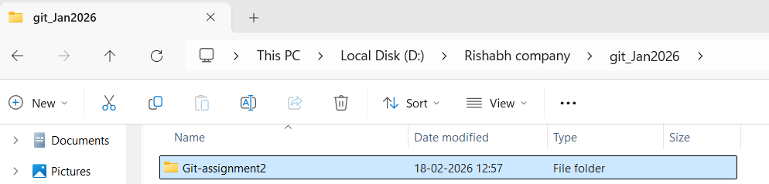
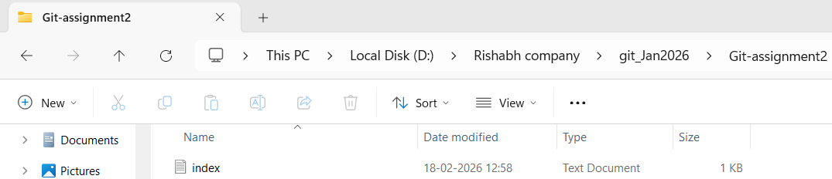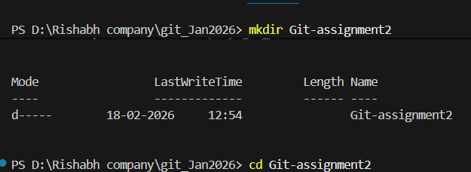
- Initialize Git in the folder.

- Create a file named index.txt
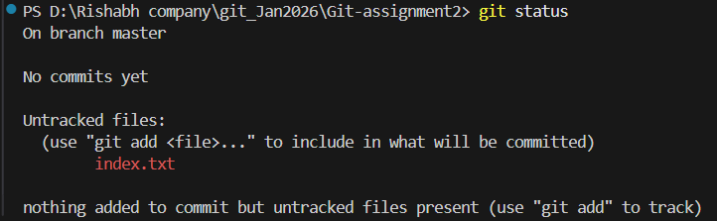
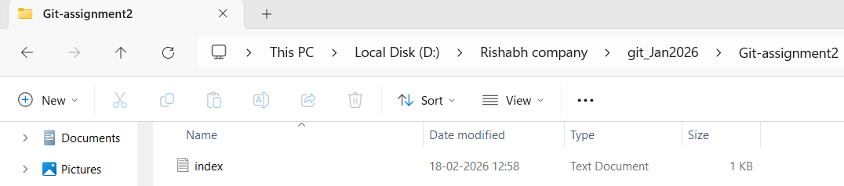
- Add content to the file.
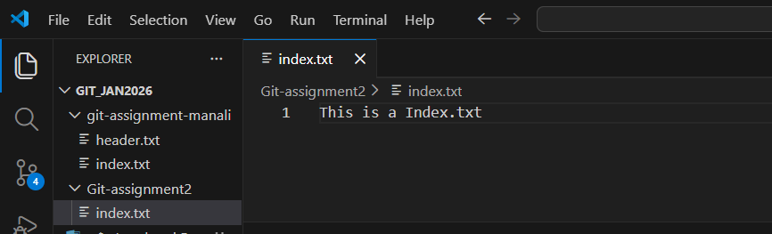
- Check repository status.
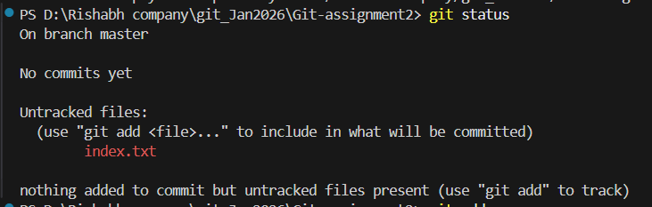
- Stage all changes.
- Commit the changes with an appropriate message.
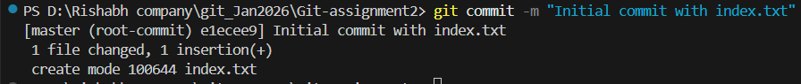

TASK 2: Remote Repository Creation
- Create a new GitHub repository.
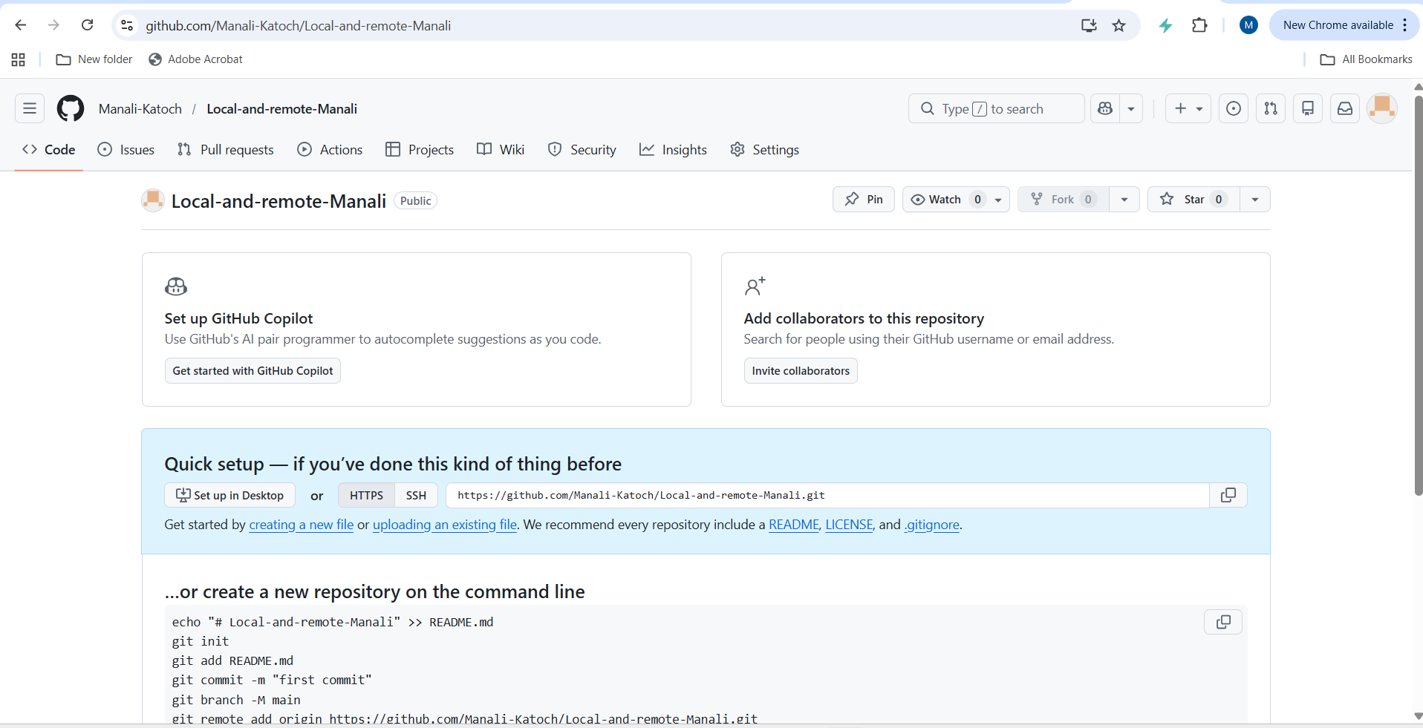

TASK 3: Connect Local Repository to Remote
- Add the GitHub repository as remote origin.
- Verify remote connection.
- Rename the current branch to main.

TASK 4: Push Local Changes to Remote
- Push the local main branch to the remote repository.
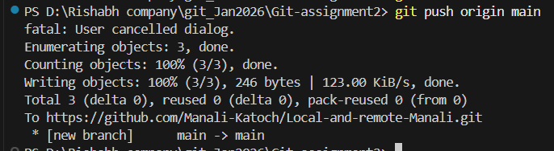

TASK 5: Branch Creation and Work
- Create a new branch named FirstBranch.
- Switch to the newly created branch.
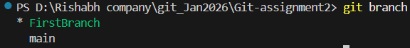

- Create a new file named notes.txt.
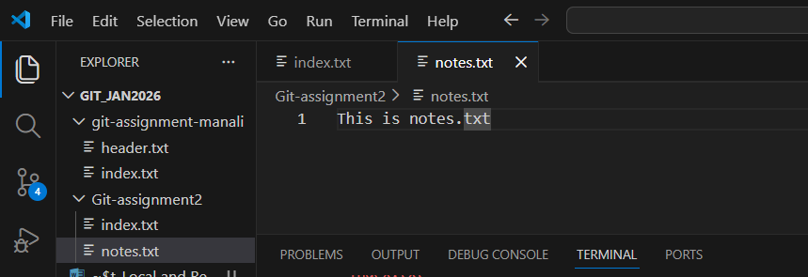
- Add content to the file.
- Stage the changes.
- Commit the changes.

TASK 6: Merge Branch into Main
- Switch back to the main branch.
- Merge FirstBranch into main.
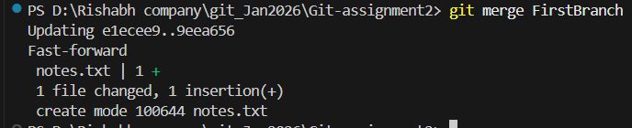

TASK 7 – Final Sync with Remote
- Push the updated main branch to the remote repository.
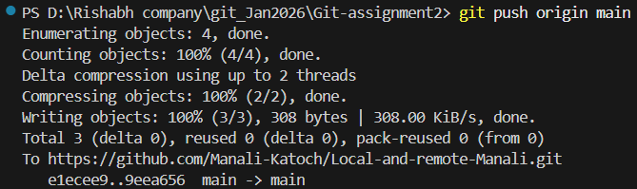

TASK 8 – Simple Pull
- Navigate to the correct local Git repository folder.
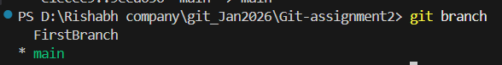

- Verify the current branch is main.
- Check the working tree status.
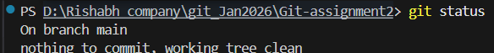
- Pull the latest changes from the remote repository.
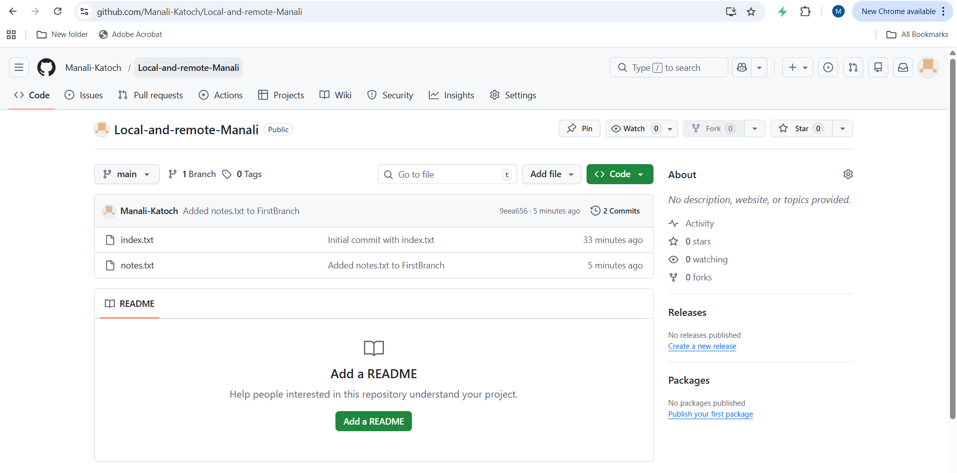
- Verify that the pull is successful.
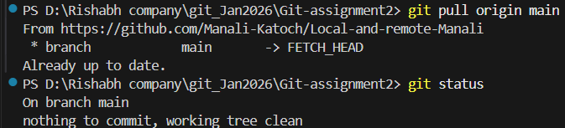

TASK 9 – Push and Pull with Conflict Resolution
- Navigate to the correct local Git repository folder.
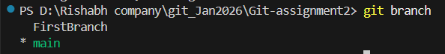
- Ensure you are on the main branch.
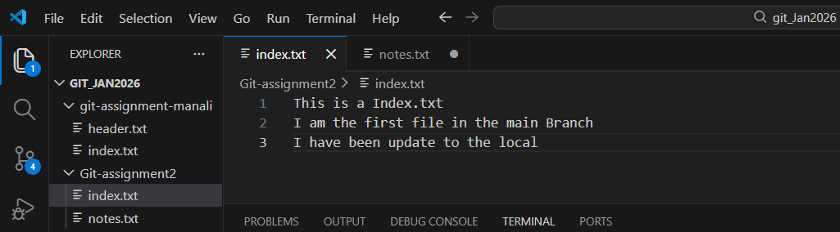
- Change the content of the index.txt file and save the changes
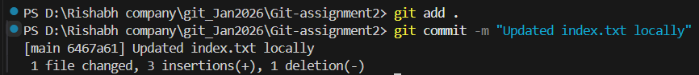
- Navigate to the correct remote Git repository folder.
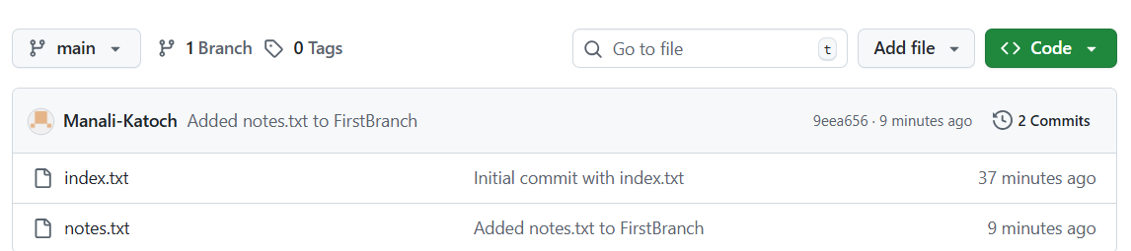
- Ensure you are on the main branch.

- Change the content of the index.txt file and save the changes
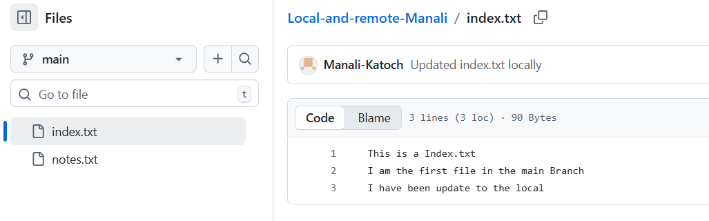
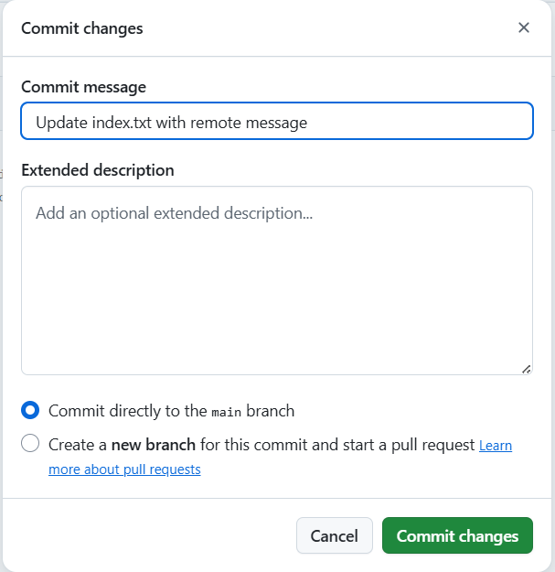
- Attempt to push local changes to the remote repository.
- Observe the push rejection error.
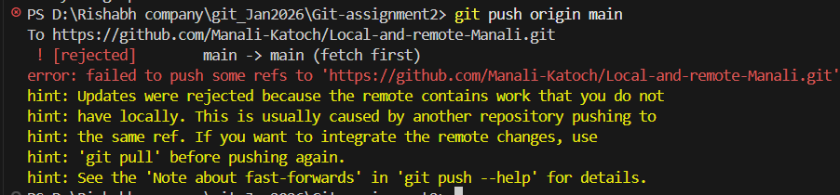
- Pull remote changes into the local branch.
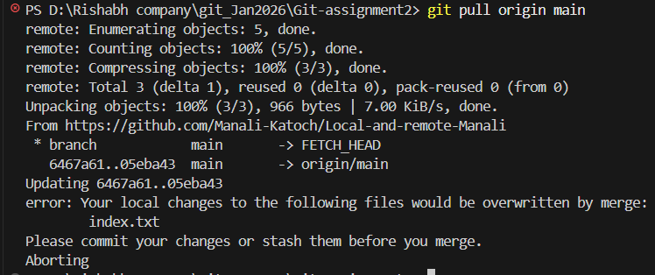
- Resolve merge conflict if it occurs.
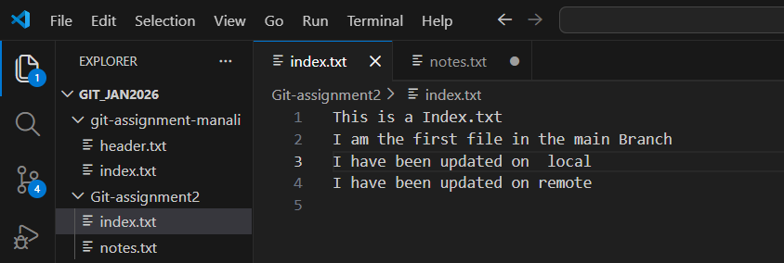
- Commit the merge resolution.

- Push the updated branch to the remote repository.
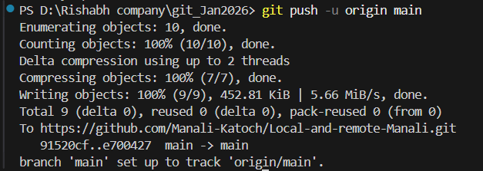

TASK 10 - Clone an Existing Repository
- Copy the GitHub repository URL.
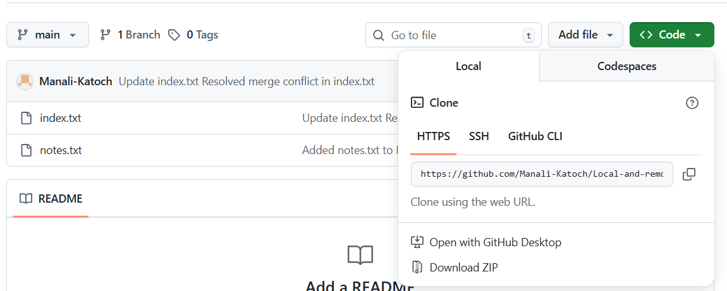
- Navigate to a parent directory (not inside another repo) in local.
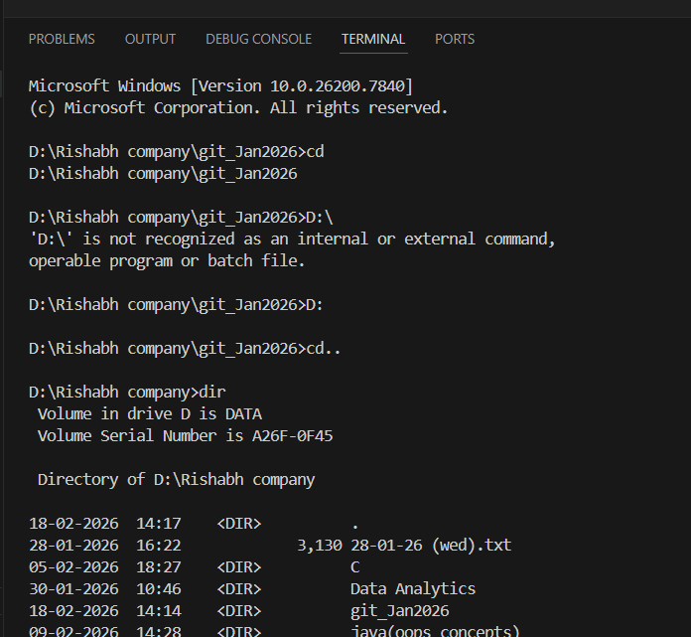
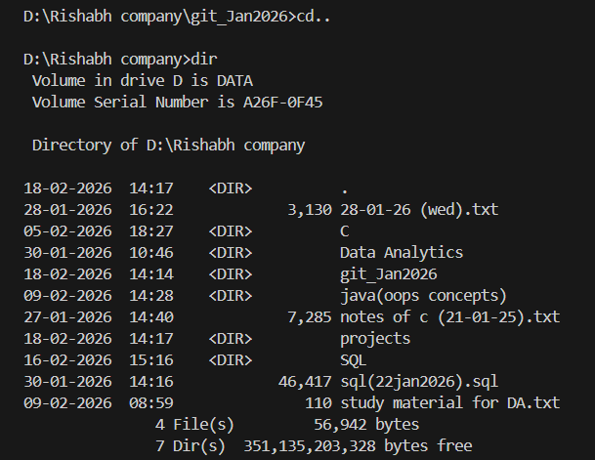
- Clone the remote repository.
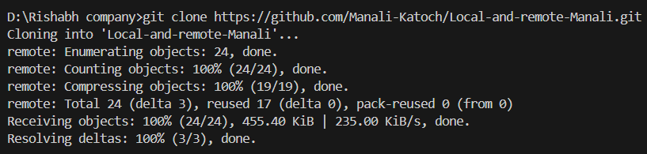
- Navigate into the cloned folder.

- Verify the current branch.
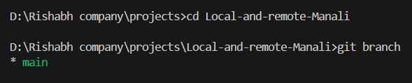
- Verify the remote connection.
